Lesson 11 Demo 5
Create a Container Registry
Objective: To create a container registry

Tools required: Ubuntu Terminal

Prerequisites: None
This section will guide you to:
- Create a container registry

Step 1: Log in to the Azure portal at https://portal.azure.com
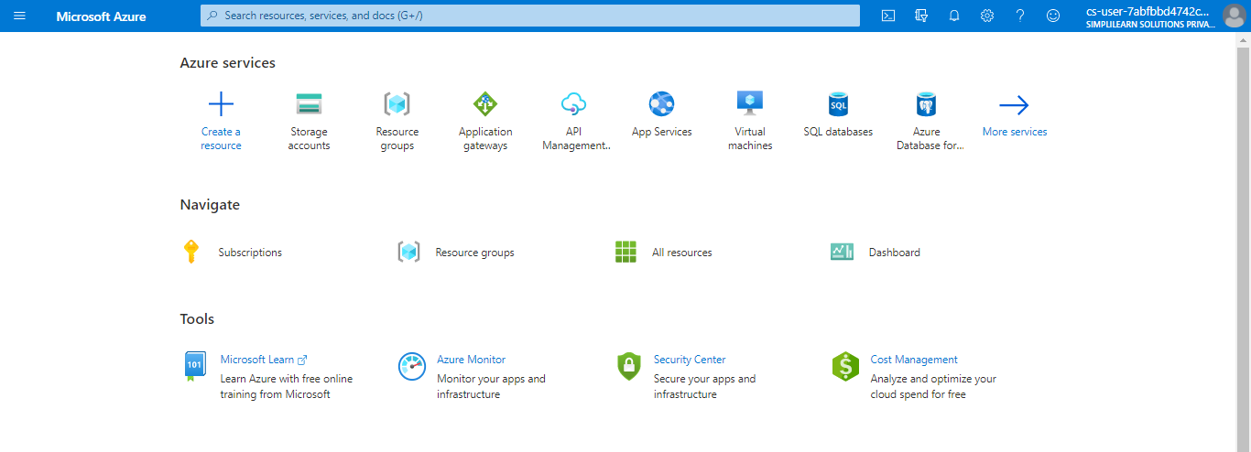

1.1 Click on Create a resource , then click on Containers, and select Container Registry
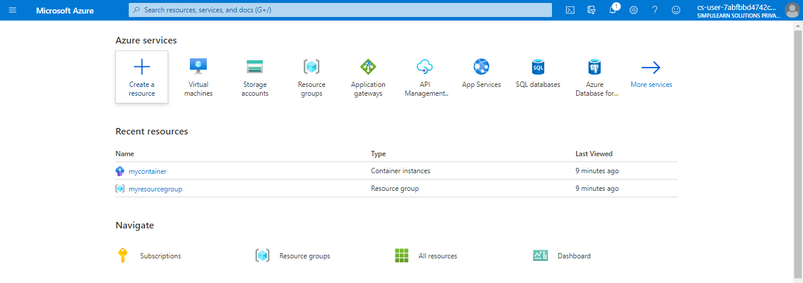

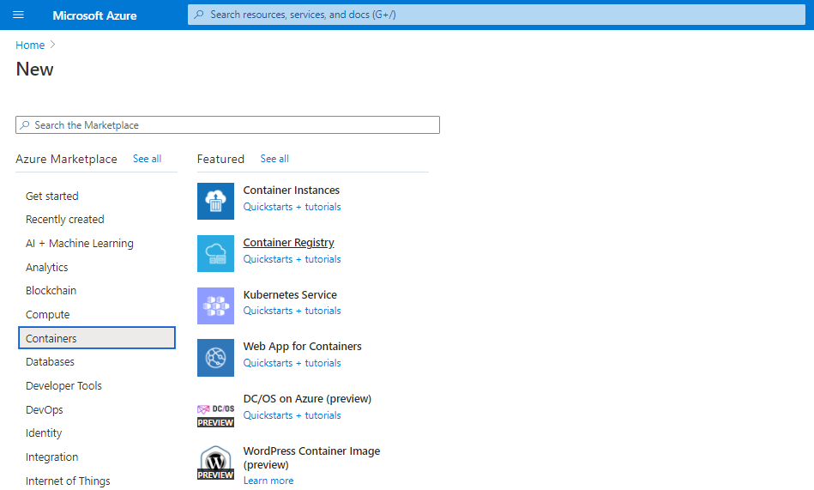
1.3 In the Basics tab, enter the following values:
1.3.1 Resource group: Click on Create new and enter Name (This should be a unique name)
1.3.2 Registry name
1.3.3 Location
1.3.4 SKU
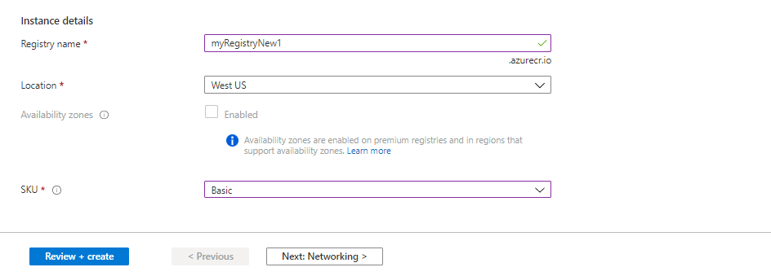

1.4 Accept default values for the remaining settings

1.5 Click on Review + create
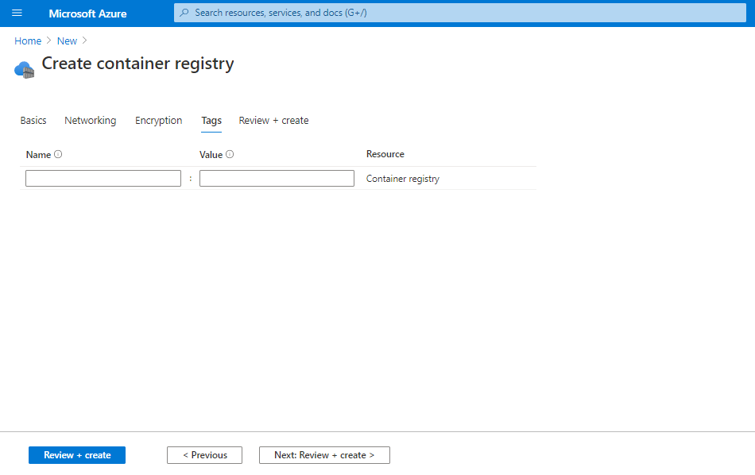

1.6 After reviewing the settings, click on Create
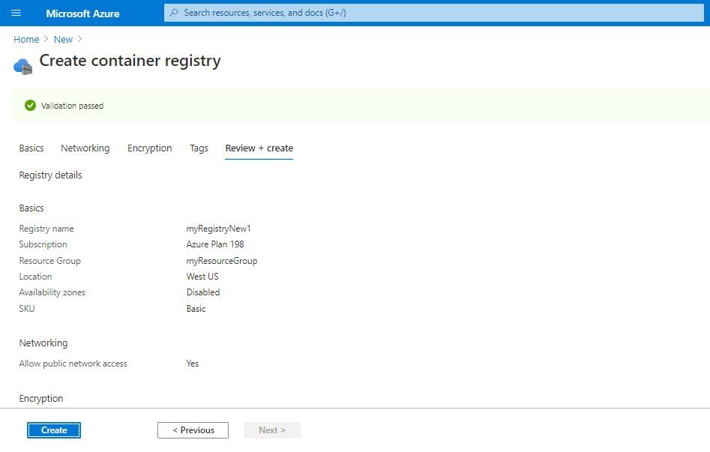

The Container registry will get deployed.
